Assignment No. 3

Title of Assignment: Write a function to get the number of vertices in an undirected graph and its edges. You may assume that no edge is input twice.
- Use adjacency list representation of the graph and find runtime of the function
- Use adjacency matrix representation of the graph and find runtime of the function.
Relevant Theory:
Adjacency Matrix:
Adjacency Matrix is a 2D array of size V x V where V is the number of vertices in a graph. Let the 2D array be adj[][], a slot adj[i][j] = 1 indicates that there is an edge from vertex i to vertex j. Adjacency matrix for undirected graph is always symmetric. Adjacency Matrix is also used to represent weighted graphs. If adj[i][j] = w, then there is an edge from vertex i to vertex j with weight w.
The adjacency matrix for the above example graph is:
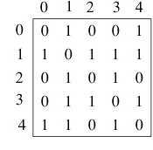
Pros: Representation is easier to implement and follow. Removing an edge takes O(1) time. Queries like whether there is an edge from vertex ‘u’ to vertex ‘v’ are efficient and can be done O(1).
Cons: Consumes more space O(V^2). Even if the graph is sparse(contains less number of edges), it consumes the same space. Adding a vertex is O(V^2) time.

Adjacency Lists: Adjacency list representations of graphs take a more vertex-centric approach. In an adjacency list representation, An array of linked lists is used. Size of the array is equal to number of vertices. Let the array be array[]. An entry array[i] represents the linked list of vertices adjacent to the ith vertex. This representation can also be used to represent a weighted graph. The weights of edges can be stored in nodes of linked lists.. Following is an example undirected graph with 5 vertices.
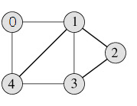
Following is adjacency list representation of the above graph.
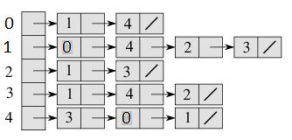

Pros: Saves space O(|V|+|E|) . In the worst case, there can be C(V, 2) number of edges in a graph thus consuming O(V^2) space. Adding a vertex is easier.
Cons: Queries like whether there is an edge from vertex u to vertex v are not efficient and can be done O(V).

Mathematical Modeling:
Adjacency Matrix:
A Є{0,1}^{n×n} with A(i , j)=[(i,j) ЄE]
Where
A : adjacency matrix
n: Number of vertices
E: Set of edges

Adjacency List:
G ={V, E}
Let V be a set of vertices
E be Set of Edges.
Then L={List(v)} where List(i) is linked list of all the nodes j where (i,j) ЄE
Testing:
Input:
Number of vertices and source and destination between edges.
Output:
Adjency matrix and List represented Grapg.
Conclusion: Graph is successfully implemented using adjacency list and adjacency matrix.

